Assignment 12

Q.1 Write a query that selects all customers whose rating are equal to or greater than any of ‘Serres’.

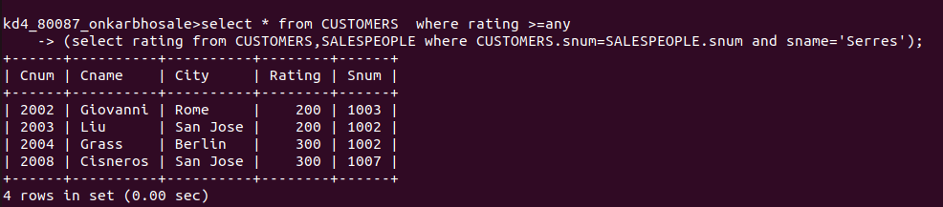
Q.2 Write a query using any or all that will find all salespeople who have no customers located in their city.
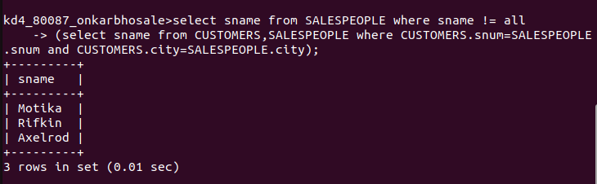

Q.3 Write a query that selects all orders for amount greater than any for the customers in London.

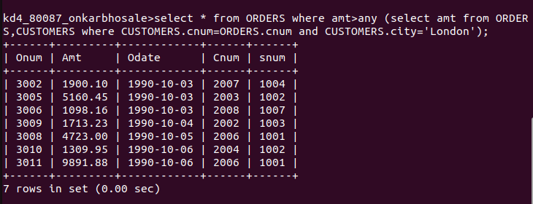
Q.4 Write the above query using min or max.
